|  |
| --- |
| **Deployment of templates in VMWare vCenter** |

Introduction 1

Settings for deployment of templates member of the domain 2

# Introduction

The following VMs and virtual appliances can be deployed, some of which are deployed automatically through scripts, others manually as needed:

* Clients:
  + All personal clients (<ves>-CAPTAIN01, <ves>-CHIEF01, <ves>-ELEC01,...).
  + The management VM (<ves>-MGMT01). This VM should be given two virtual network interfaces in the Admin_Trust & Security VLANs.
* Linux Servers:
  + CommBox (<ves>-COMMBOX01).
  + Artica Proxy (<ves>-PROXY01). This VM only has a virtual network interface in the Security VLAN.
  + UPS management (<ves>-UPSMGMT01).
  + vCenter (<ves>-VCENTER01).
  + AXI server (<ves>-AXI01)
* Windows Servers:
  + Application server (<ves>-APPS01).
  + Secondary AXI application server (<ves>-APPS02).
  + Backup server (<ves>-BACKUP01). This VM should be given two virtual network interfaces in the Admin_Trust & Backup VLANs.
  + Domain controller (<ves>-DC01). This VM obviously cannot be joined to the domain using the instructions below and should be deployed from the specially prepared template.
  + File & print server (<ves>-FILE01).
  + Monitoring server (<ves>-MONITOR01).
  + Task server (<ves>-TASK01).

Routine VMs only have network interfaces in the Admin_Trust VLAN.

VMs which are client of the domain can be added automatically to it, as described below.

# Settings for deployment of templates member of the domain

Right click the template you wish to deploy & select “*Deploy Virtual Machine From This Template*”.

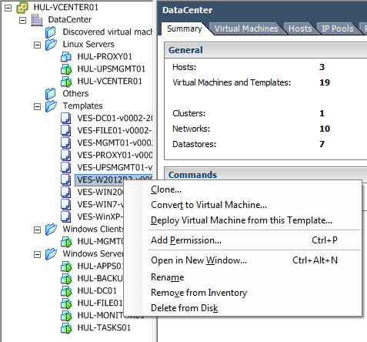

Enter the VM host name and select the folder in which the VM should be placed.

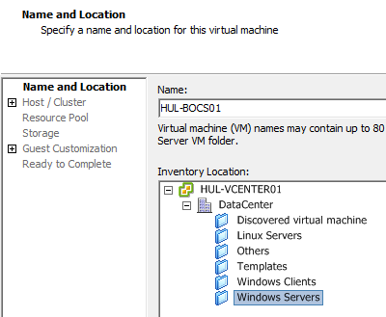

Select the cluster in which the VM will be placed.

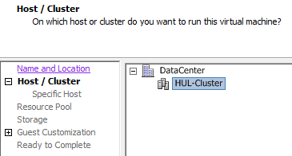

Select the host on which the VM should be deployed.

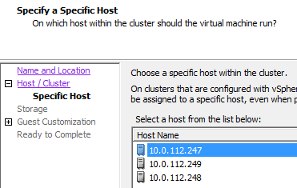

First select the datastore on which to place the VM. This should never be a local datastore if you’re using a clustered environment, since high availability will fail when using local storage.

Then adjust the virtual disk format to “*Thick Provisioned Eager Zeroed*”. Never use Thin Provisioning as this requires constant monitoring & manual action to remediate in case of issues.

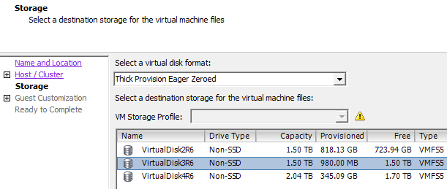

Select “*Power on this virtual machine after creation*”.

Then select “*Customize using an existing customization specification*” if you wish for the VM to be automatically added to the domain.

Select the relevant customization from the list.

If you are unsure the customization profile is the right one, check the check box with “*Use the Customization Wizard to temporarily adjust the specification before deployment*”. This can also be used if you do not want the VM to use DHCP, but should use a fixed IP instead.

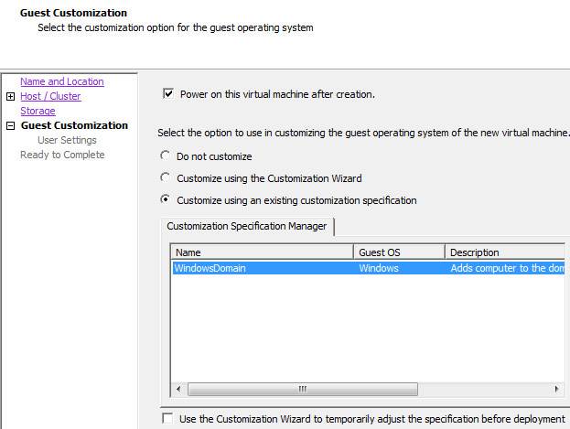

Review your choices. If you wish to change the network on which the VM will be placed or if you wish to assign more/less resources, check the checkbox with “*Edit virtual hardware*”.

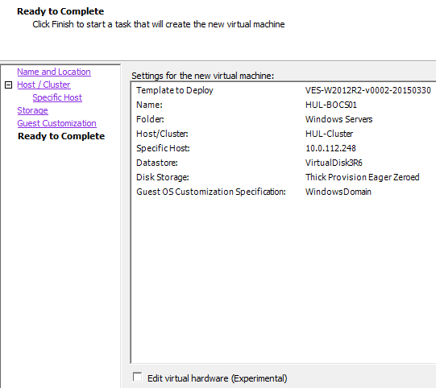

In the task overview, you will now see “*Copying Virtual Machine files*”. Due to using Thick Provisioned Eager Zeroed, the disk will first be created, which will increase deployment time. Only after the disk has been fully formated, the actual image will be copied.

After this is complete, the VM will start. The VM will then reboot within 2 to 15 minutes to apply the customization. Shutting down the VM or otherwise interfering with the customization can prevent it from working correctly.

Be sure to move the added VM to the correct OUs once it’s joined the domain.